ANIMAL AND PLANT CELLS

Cells are the basic units found in all living things.

The following labelled diagrams of a plant and animal cell must be remembered

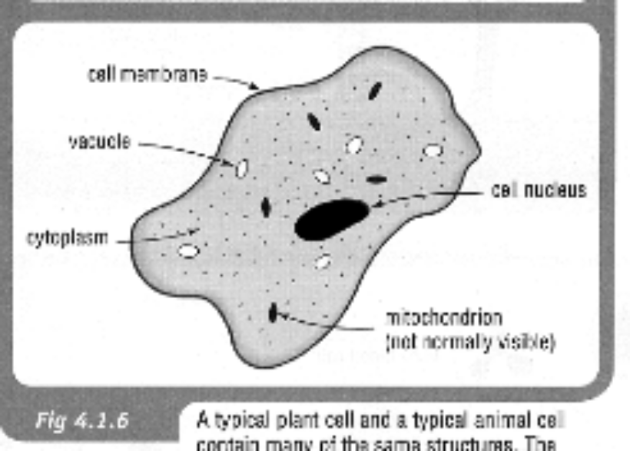
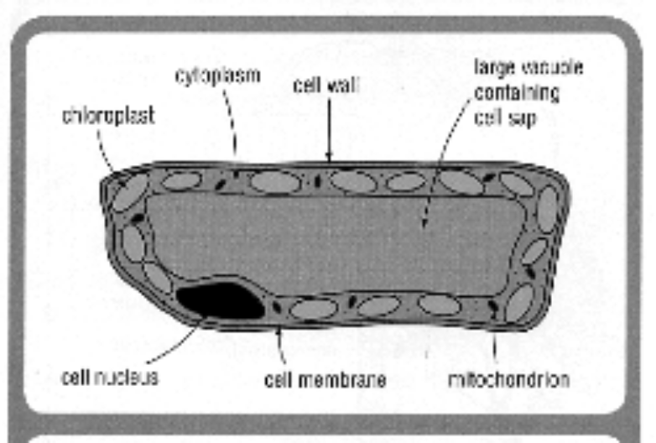

Activity

Complete the following tables using Ch. 3.3 of Science Quest 8 textbook.

Part of Cell | Function
cell membrane
nucleus
cytoplasm
mitochondria
vacuole
cell wall
chloroplasts

Features Common to All Cells | Differences Between Plant and Animal Cells

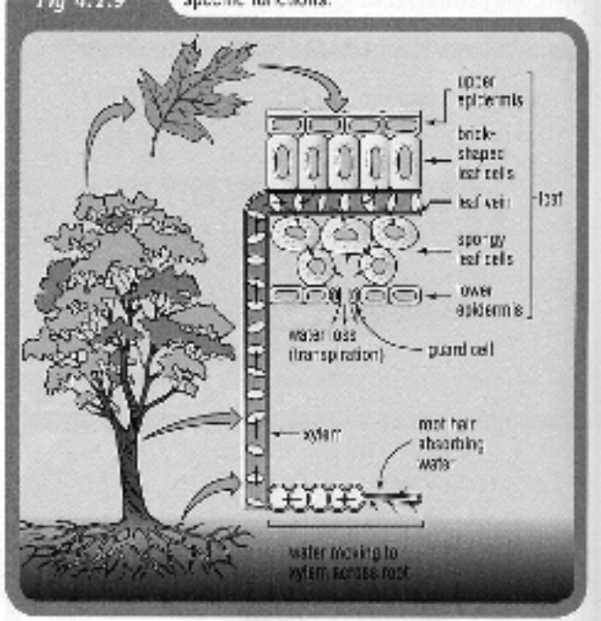
Specialised Cells

Both plants and animals have specialised cells that have a particular function in the organism.
The following diagrams show some of them.

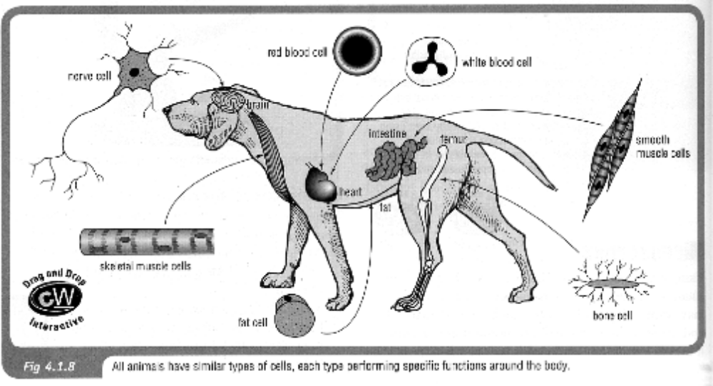
e.g. Plants - xylem, phloem, guard cells, root hair, etc.

Animals - nerve cells, red and white blood cells,
smooth muscle, bone cells, etc.

